https://staff.polito.it/michele.ferlauto/inverso.html

INVERSE PROBLEMS IN FLUID DYNAMICS

Usual CFD analysis tools solve a direct aerodynamic problem. The geometry of the aerodynamic surface as well as the necessary boundary are known. The flowfield is then computed numerically.
In an Inverse Problem instead, the geometry is unknown and some flow features, e.g. the pressure distributions, are prescribed at the boundary of the aerodynamic device, whose shape is then sought.

From the mathematical point of view, the formulation of an inverse problem is the natural way of solving the design problem. In pract ice, the formulation of the inverse problem is complicated by well-posedness issues and the numerical solution often requires complex and CPU-expensive algorithms.
The approach we propose of solving aerodynamic inverse problems identifies the problem solution as the steady state of an unsteady evolution. During this transient, the flowfield tries to accommodate itself to the design data, which are prescribed as boundary conditions on the unknown surface. To do this, the surface is allowed to move. From the computational stand point, this approach requires the numerical solution of the flow governing equations on a flow domain changing in time. The algorithms for compressible and incompressible flow differ because a different numerical treatment of the flow governing equations is required.

Inverse problems based on the incompressible Euler equations

Let us consider, for instance, the design of a stator blade. One can rely the desired performance to a certain blade load. The solution strategy is therefore to start from an initial guess of the blade geometry and to impose the desired load. For each surface element, the numerical procedure derives the wall motion that tends towards the satisfaction of the boundary conditions. The blade surface is then integrated in time, until a steady state is reached. If this happens, the geometry that realizes the desired load conditions is found.
In Figure 1 the solution process for the design of a stator blade is illustrated: to the initial guessed geometry (a) the blade load distribution is applied; since pressures in the neighbourhood of the blade is not in accord to the imposed wall pressure, blade surface start moving in order to decrease the pressure gap (b)-(c). At convergence the steady state (d) is reached. At (d) the flowfield satisfies the imposed BCs, so that the shape does not change anymore in time. The dynamics resembles the motion of a flag under the action of a constant wind.

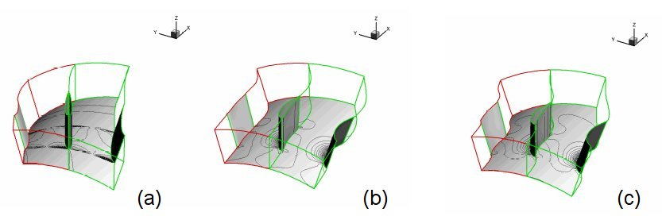 | 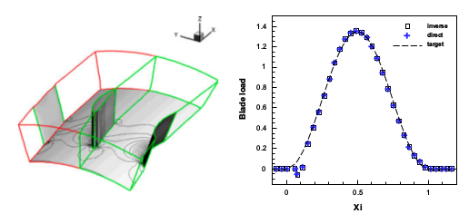
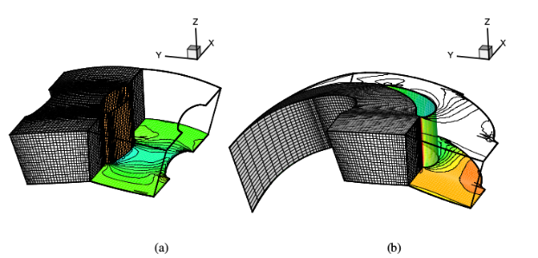 | 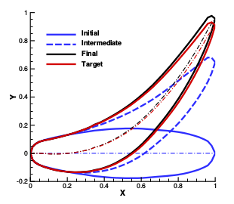
FIGURE 1: Solution of a 3-D inverse problem based on the Euler incompressible equations.
(a) Initial guess, (b)-(c) intermediate and (d) final 3-D blade geometry and flowfield.

Inverse problems based on the compressible Euler equations
Although there are substantial differences in the numerical aspects with respect to the incompressible case, the solution of the inverse problem for compressible flows follows the same footsteps. We prefer to focus here our attention to a special application of the method. Other design problems will be shown using the full Navier-Stokes equations. The inverse problem can be used to accurately fit fluid interfaces in supersonic flow. This becomes important, for instance, when computing the plumes of supersonic nozzles, where the out-coming flow interacts with the external flow and a very complex scenario take place. Under-resolved fluid interfaces can affect the flow pattern generated by the highly non-linear interaction between shocks, expansion waves and fluid interfaces. In Figure 3 an over-expanded two stream nozzle interacting with the external flow is shown
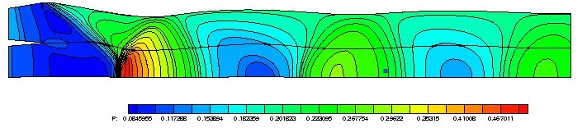

FIGURE 3: Flow on a over-expanded two-stream nozzle interacting with the external flow.

Inverse Problem based on the Navier-Stokes Equation
With substantial changes, related to the different flow physics and boundary condition involved in, the above-mentioned approach to the solution of the Inverse Problem applies to the Navier-Stokes equations. In the following the inverse design of a supersonic dual-bell nozzle and of a spike nozzle are illustrated.
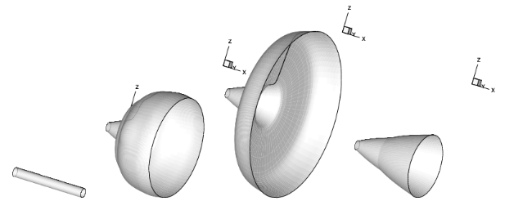 | 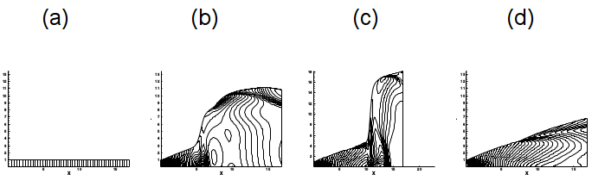
FIGURE 4: Design of a Dual bell nozzle by an Inverse Method. (a) Initial guess, (b)-(c) intermediate and (d) final geometry and pressure field

https://staff.polito.it/michele.ferlauto/optim.html

TURBOMACHINERY DESIGN & OPTIMIZATION
In this section, the application of advanced design techniques and of optimization are considered. Aggressive design of turbomachinery components is concerned. The optimization strategy is based on the coupling of non-traditional design techniques as inverse methods and adjoint optimization. The adjoint solver drives the inverse design procedure to optimal configurations, while it avoids the well-posedness issues. In fact, the inverse solver and the optimizer are based on the flow governing equation and on its adjoint.

Design of Optimal Diffusers.
Design of a flow separation resistant diffuser with minimum deviation at the outlet. The shape of the diffuser with uniform outflow direction is sought. To avoid flow separation in the full range of working conditions, the pressure gradient at wall is constrained according to a separation criterion. The computational approach is based on a continuous adjoint optimization that drives the sequence of inverse problems. In Figure 1(a) the pressure distribution of the diffuser wall is displayed. The initial pressure distribution corresponds to the diffuser geometry of Figure 1(b), obtained by solving an inverse problem. The optimal pressure distribution corresponds to the solution of Figure 1(d).
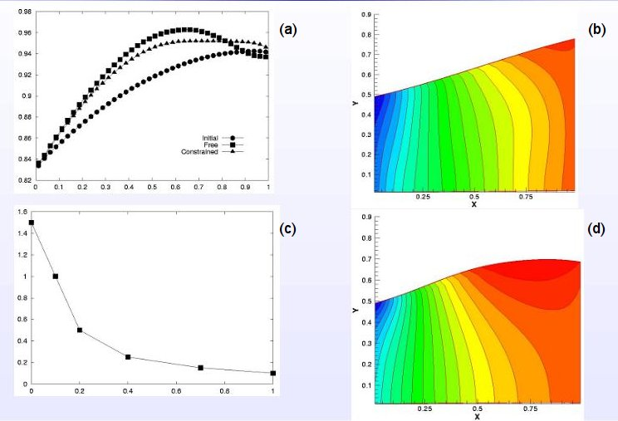

FIGURE 1: Diffuser with minimum outlet deviation. (a) Pressure distribution at wall during the optimization process. (b) Initial diffuser geometry, (c) constraint on the maximum pressure gradient along the diffuser wall, (d) optimal diffuser.

Simultaneous Design of Multistage Axial Compressors or Turbines
A modelling approach for deriving the flow inside a multistage axial gasengine is presented in this section.
By introducing the axis-symmetry hypothesis, the Euler equations are reduced to a quasi-2D formulation. Therefore, the flow inside an axial turbomachine can be represented into the meridional plane. In present model, the action of stator and rotor blades are replace by volume forces. If an analysis problem is concerned, given the blade geometry the blade forces are found. In the design problem instead, we prescribe these forces nd the blade shape is found by solving an Inverse Problem. Since the geometry of all the blades,i.e. rotors and stators, are found simultaneously, the flowfields generated by the blades are automatically in accord each other. The numerical approach follows the footsteps of the previous case. A numerical solution of the continuous adjoint of this flow problem has been derived. The adjoint solver is used for finding optimal blade force distributions. The shape of the blade camber surfaces are then obtained simultaneously, by solving the inverse problem. Viscous effects, blade blockage and losses are taken into account by distribute loss models.
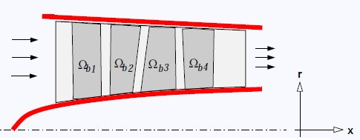 | 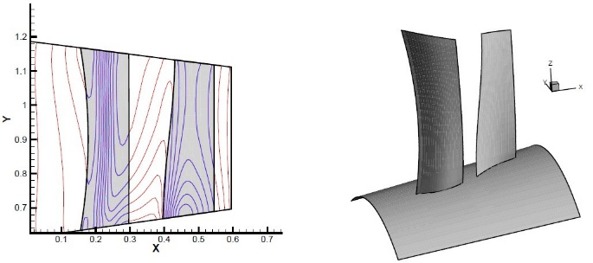
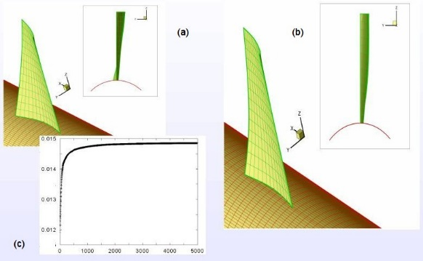 | 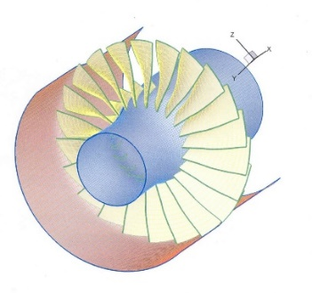
FIGURE 2: Aft-swept fan rotor. Pressure field (a) and blade geometry (b). The gray regions represent the blade projection onto the meridional plane, i.e. the blade planform. FIGURE 3: The optimization of an unducted propfan at flight Mach number M=0.6 . (a) Initial guess, (b) optimal geometry, (c) thrust versus optimization steps. FIGURE 4: Optimization of transonic fan for lowering the noise. Starting point was the NASA rotor 37.

Inverse problems based on the incompressible Euler equations

Inverse problems based on the compressible Euler equations

Inverse Problem based on the Navier-Stokes Equation

Simultaneous Design of Multistage Axial Compressors or Turbines

Thermal Inverse Problem on a Coated Cylinder with internal heating

Inverse Problem on the MARK-II Turbine Blade.

Inverse Problem on a Multi-holed Coated Turbine Blade. (PDF)

Unsteady Heat Transfer Problems: Brake Disc Thermal Analysis

An Inverse Method of Designing the Cooling Passages of Turbine Blades Based on the Heat Adjoint_Ferlauto_2013 (PDF)

A PSEUDO-COMPRESSIBILITY METHOD FOR SOLVING INVERSE

PROBLEMS BASED ON THE 3D INCOMPRESSIBLE EULER EQUATIONS (PDF)

A CFD Method for Optimal Air-Intake Design (PDF)

A viscous inverse method for aerodynamic design

Inverse Problems for Advanced Nozzle Design

A viscous inverse method for aerodynamic design

FAN AND PROPELLER DESIGN VIA INVERSE PROBLEM ADJOINT EQUATIONS (PDF) (SEE)

Impeller Design and Performance Analysis of Aviation Fuel Pump Based on the Inverse Method

https://staff.polito.it/michele.ferlauto/inverso.html … continuing … author’s other cases HEAT TRANSFER
Thermal design problems related to turbomachinery components and propulsive systems are here concerned. We are interested mainly in the thermal design of coated turbine blades, a design problem that is approached here by an inverse method. Other unsteady heat transfer problems are also investigated numerically by FEM analysis. For example, the analysis of an automotive wheel + brake system during the fading test case is illustrated.

Thermal Inverse Problem on a Coated Cylinder with internal heating
The solution of the thermal field in a coated hollow cylinder with prescribed outer boundary temperature, and heat convection rates at the inner flow passage can be derived analitically. This fundamental solution is often used to test accuracy of numerical methods. In our case, we builded up a test case to validate our thermal design procedure based on an inverse method. The procedure aims to derive the shape of the coolant/heating channel that realizes, for instance, a prescribed temperature distribution on the outer boundary of the solid domain. Once the inverse problem is solved numerically, both the channel geometry and the thermal field can be compared to this simple analitical solution to check the accuracy.
An initial geometry of the channel in the solid domain is guessed. As visible in Figure 1, we selected a very small circular hole in a non-symmetric position. The numerical results converged to the analitic solution, with a perfectly radially symmetric thermal field

Inverse Problem on the MARK-II Turbine Blade.
The inverse procedure has been validated against a more severe test based on experimental results about the MARK-II turbine blade. Now were are ten cooling channel of circular shape. The test-case working conditions have been imposed at the boundaries, on the initial guess of the coolant channels position and dimension. At convergence, the inverse procedure was able to find the correct location and dimension of the coolant holes.

Inverse Problem on a Multi-holed Coated Turbine Blade.
The same approach is applied to teh design of a more realistic configuration of a modern coated and cooled turbine blade. The Thermal design of the multi-holed turbine reqiires a different parametric formulation of the inverse problem. The test follows the same guidelines of previous example.

Unsteady Heat Transfer Problems: Brake Disc Thermal Analysis
The FEM core of the solver developed for the inverse procedure of thermal design is also able to compute the unsteady thermal field on domain of complex shape. As example, the temperature field evolution and the performances of the system wheel + disc brake + calliper during a standard fading test are proposed. Fluid dynamics related parameters have been derived by CFD simulation of the wheel aerodynamics.

